Project Two

Joshua Shults
SNHU
Dat-300: Data Valid: Getting Right Data
Joy Alatta
10/13/2025

Introduction
This report aims to conduct a gap analysis on our organization’s sales dataset. The purpose of the gap analysis is to determine any limitations that are affecting a proper analysis to be done on profits, inventory management, and any potential insights we can use for revenue growth. The currently available data set will be used for this gap analysis, and all visualizations were built from what information we currently have.
Which products will yield the highest profit margin?
This question can be answered with the current data set, although improvements can be made. Below I have included a visualization of sale totals, excluding tax, by stock item with a line denoting profit. The highest selling items are shown in a deep blue. While the air cushion machine has the highest volume of sales, its profit margin is only 40%. The second highest selling item, 32 mm anti-static bubble wrap (blue) 50m, has a profit margin of 55%. The fourth highest selling item in the visualization, 20 mm double sided bubble wrap 50m, has the largest profit margin at 85%.

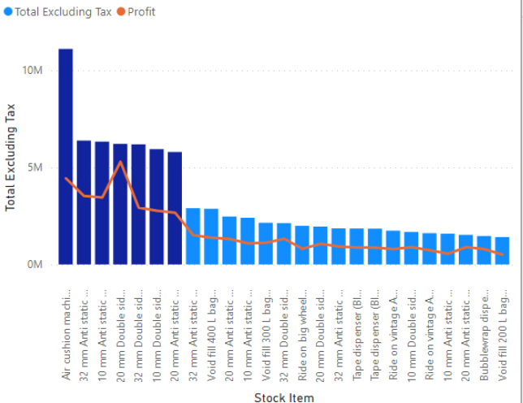
(Above: Total excluding tax by stock item, with profit shown in an orange line. The darker blue columns are the highest sellers.)
In which months do we need to ensure that inventory levels for key products are highest?
This is where I have found the first major gap. Any attempts I made at using dates and sale totals led to visualizations that only show the complete total, not separated by month. I tried analyzing profit by month, quantity by month, total by month, none of these built a visualization that gives any information, as each column showed the same amount. Under the sale header there is a delivery date that can be used to build a visualization properly, however delivery dates can produce skewed information. An item can be ordered two months prior to its delivery date, so the information I can gain from this is limited as there is an amount of uncertainty in it. Below I have included the visualization of total by delivery date month. June and July are colored in pink; they are the beginning of the upward trend in delivery dates. This suggests that we have increased activity during the summer months leading into early fall, though we need further validation once required date data is supplied that has a working relationship with sales. August, September, and October, colored orange, are the months with the largest numbers of deliveries. During these months we need to ensure that inventory levels for key products are at their highest. However, this data is not entirely accurate and should be viewed as potentially incorrect.
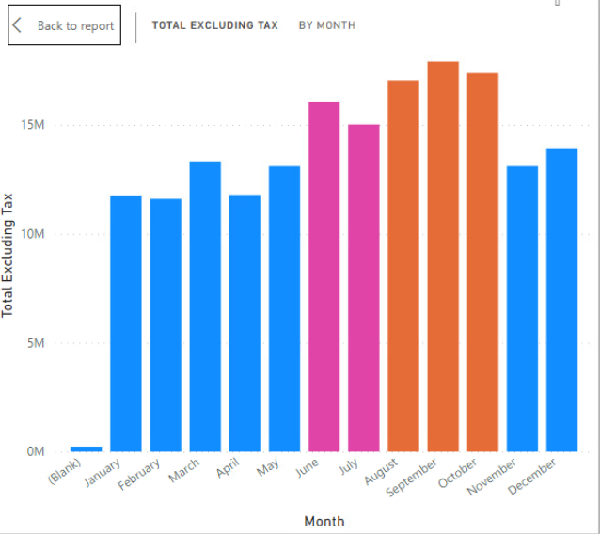
(Above: sales totals, excluding tax, by delivery month)
How can we grow our business in terms of revenue growth?
This question also exposes another large gap. In the data set I have access to, I have no way to see any marketing strategies to determine if they were or were not effective, there is no data on when any major discounts might increase sales and weigh this against profits to determine if they are successful, nor any other data I could use. This set seems to only include raw numbers, which can be analyzed, but including items like I listed above would provide a better picture of what is affecting our sales positively or negatively. There is one item that could be useful if it were more complete, which is brand. Brand contains two entries, Northwind or not applicable. By making a pie chart we can see that Northwind, colored in deep blue, makes up about 7% of our total profit at a total of 6.06 million. However, that leaves the other ~93% of profit, almost 80 million, completely unaccounted for in terms of selling brands. There is no way to gain further insights from this, we can only guess that Northwind is a good brand, we can’t confirm this against any other brands we offer.
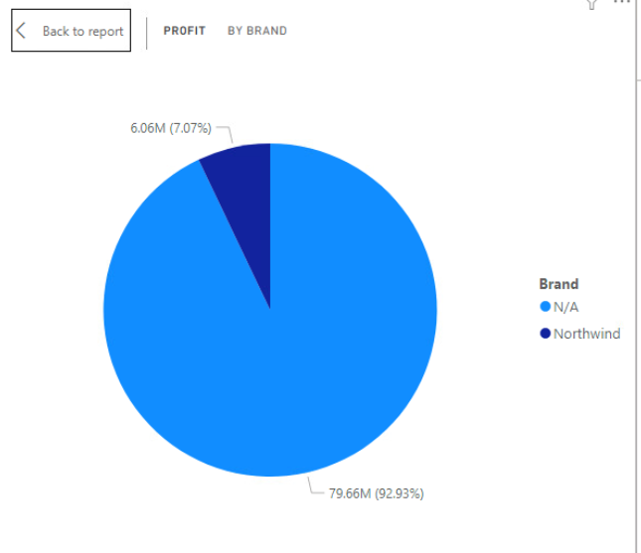
(Above: Pie chart of profit by brand)

Gap Analysis Visual
Desired State | Current State | Action Steps
Understanding which products yield the highest profit margins | Profit margins per stock item is available in the set. However, categories can be introduced to see what types of products sell the most in a group. Whether or not items are discounted should be included to enhance any insights into why the product is selling, and how it affects profits. | - Add categories to the data set  - Add any data relating to deals on items, such as if the item was bought on sale

Desired State | Current State | Action Steps
Understanding in which months we need to monitor inventory levels to meet demand | The date field is not recognized properly currently. Power BI is aggregating the entire dataset together rather than allowing a breakdown of month-by-month sales. | - Verify and clean the date field  - Create a date table to make a relationship between sales info and dates  - Rebuild visualizations with sales and profit by month when the date key is properly related in the set

Desired State | Current State | Action Steps
Determine how we can grow our business in terms of revenue | Currently there is no valuable information in the set that provides insights into how the business is performing. Currently, only sales and profit numbers exist, which are invaluable information but do not provide the entire picture. Marketing information, deals, and categories can enhance our ability to make business decisions once they are present. | - Add additional data sources such as marketing, discounts, and other details to gain context into what exactly drives sales  - Add a category field to group sales and analyze which categories contribute most to profits

Summary Paragraph
The gap analysis done on this data set shows that key sales and profit figures are already present, which provides the foundation for any analysis. However, several areas are lacking for any meaningful insights to be gained from them. First and foremost, the absence of a properly recognized date field limits our ability to forecast demand to plan out inventory, which could lead to a shortage during a key profit generating period. Contextual data is also missing, such as marketing information, discount records, and categories. By addressing these gaps we could enhance reports, build better visualizations, and make better informed decisions in the future.
Process Flow
Step | Action Needed | Responsible Party | Data Required
1 | Clean and verify date field | Data Analyst | Transaction dates
2 | Create date table with relationships | Data Analyst | Sales dataset
3 | Add product categories and market data | Marketing Manager / Data Engineer | Stock items, marketing campaign dates, discount percentages and dates
4 | Review and validate accuracy of new tables and entered data | Data Governance leader | All data above and newly entered data
5 | Present this new data | Data Analyst | The final data set after new data is entered and validated

ETL Process
First, we need to gather raw data from sales, inventory, and marketing systems present. Pull relevant data from these logs, such as transactions, discount records, and any marketing data. We will then transform this data by cleaning and formatting the data to ensure it is consistent with the current set. Here we will create new fields such as date hierarchies with working relationships and product categories. Finally, we will load this data into the company’s data warehouse, or cloud storage, where we can load it into Power BI workspace for visualization and analysis.
Security Measures
The data set currently has personally identifiable information held within it. This information is items such as employee names and customer names. To be compliant to standards such as GDPR and CCPA we need to ensure that this personally identifiable information is never shared or visualized without consent. Though names can be shared, the GDPR covers “personally identifiable information that can be directly or indirectly identifiable, such as a name.” (Intersoft, n.d.) For the purposes of determining business decisions such as those posed in this analysis, I can conclude that any PII is not necessary to be included at all. Therefore, I recommend personally identifiable information be stricken out as it is unnecessary for analysis. Any regional data can be generalized, as in city and state with no physical address listed unless it is that of our own business, such as a warehouse to determine exactly where products ship from, but not the physical address it arrives at other than a general city and state.

Production and Testing Environments
Production and testing environments should always be conducted in a sandbox environment. This ensures that we can prevent accidental overwriting of current data, or corrupting any live data. Using a sandbox environment in Power BI will mean that any transformations are done separate from the actual data set. This preserves data integrity and minimizes risks of skewing accurate data or losing data.
(Kangoun, n.d.)
Justification for Additional Data Resources
Bringing in these additional data resources will aid in closing the identified gaps in the report above. The data sources I request include marketing data, product category data, and a working date table that has a proper relationship and can be measured against sales and profits. These new resources are essential for analysts to gain meaningful insights into trends, as well they can be used to justify any inventory decisions made. These additions will enable us to forecast demand more accurately, determine where marketing or promotions are effective, and what exactly affects our profits.

References
Intersoft Consulting. (n.d.) GDPR: Personal Data. Intersoft Consulting. https://gdpr-info.eu/issues/personal-data
Kangoun, Alex. (n.d.) Analytical Sandboxes: A Roadmap to Data-Driven Innovation. Athena Solutions. https://athena-solutions.com/analytical-sandbox-getting-the-most-out-of-your-big-data/#:~:text=What%20is%20an%20Analytical%20Sandbox,deeper%20insight%20from%20internal%20information

